**Name >> Muhammad Huzaifa**

**Roll No >> 04**

**Assignment 6**

**20th August 2023**

**Module 2 : Front End Development (JS_Web)**

*Submission Requirements: Please upload your codes in PDF File on Google Classroom in the  relevant Assignment section.*

*Note: Plagiarism is a serious violation. Zero marks will be awarded in case plagiarism is found.* You are required to perform the following tasks.

# **Class Questions:**

* Remove direct text placed inside a div.

**Solution:**

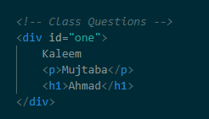

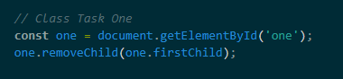

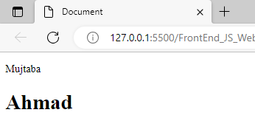

* Add/Remove text in an element based on hover and blur on button respectively.

**Solution:**

# **Part 1:**

* Use document.getElementById(id) to find an element with a specific ID and store it in a variable.

**Solution:**

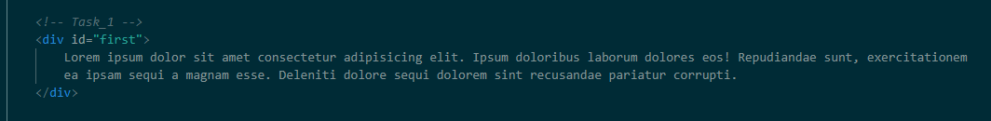

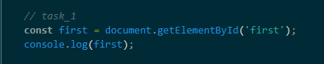

* Utilize document.getElementsByTagName(name) to find all elements with a specific tag name and log them to the console.

**Solution:**

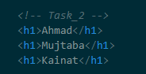



* Use document.getElementsByClassName(name) to find all elements with a specific class name and apply a CSS style to each of them.

**Solution:**

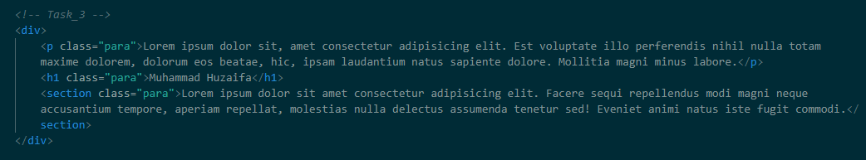

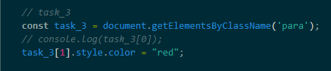



* Change the inner HTML of an element with element.innerHTML to display new content when a button is clicked.

**Solution:**

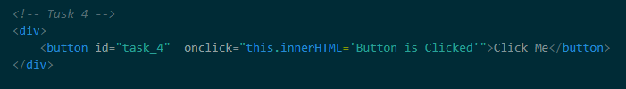

 

* Update the value of an attribute in an HTML element using the element.attribute property based on user input.

**Solution:**

* Create a function that changes the background color of an element using the element.style.property.

**Solution:**

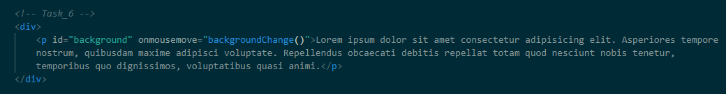

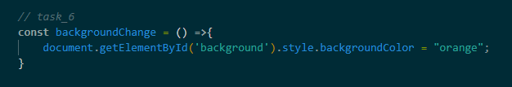



* Create a button that, when clicked, uses element.setAttribute(attribute, value) to modify the 'src' attribute of an image.

**Solution:**

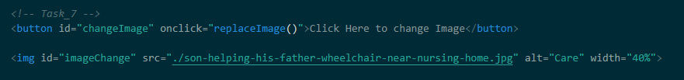

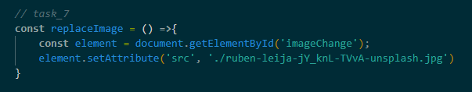



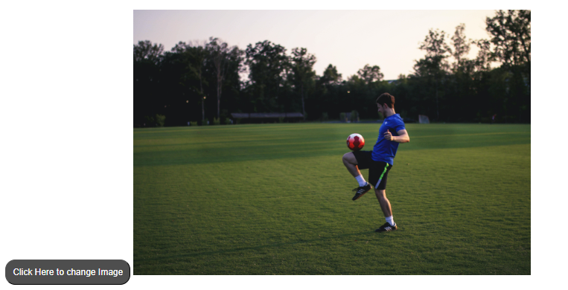

* Develop a form where users can input their name and a message. On submission, use element.innerHTML to display a personalized message.

**Solution:**

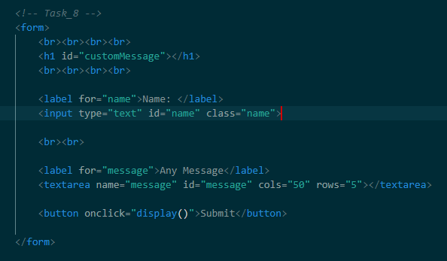

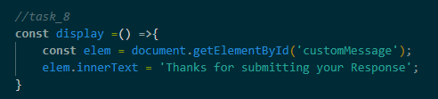

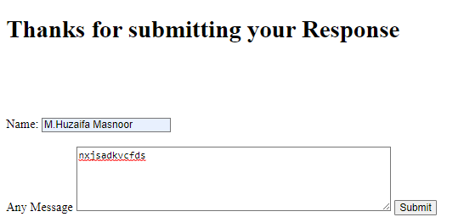

* Build a list of items with checkboxes. When a checkbox is clicked, use element.style.property to strike through the item's text.

**Solution:**

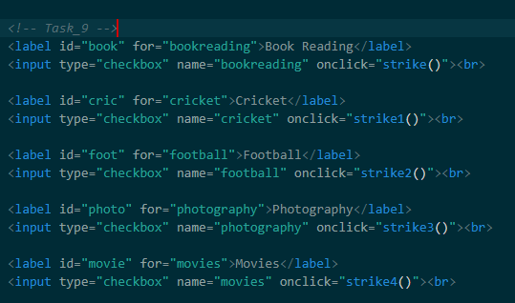

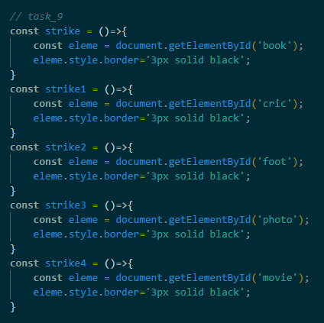

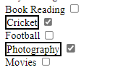

* Use document.createElement(element) to create a new paragraph element and append it to an existing div.

**Solution:**

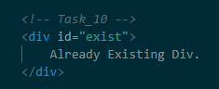

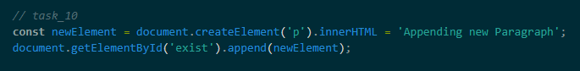



* Create a button that, when clicked, removes a specific list item using document.removeChild(element).

**Solution:**

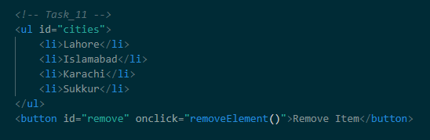

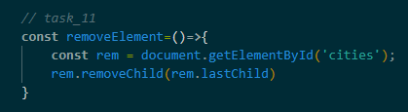

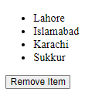 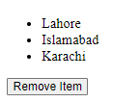

* Implement a feature that adds a new list item to an existing unordered list using document.appendChild(element).

**Solution:**

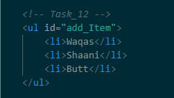

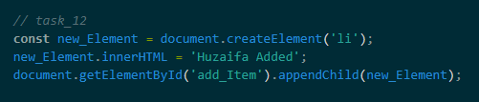

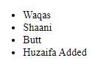

* Replace an existing image on a webpage with a new image by using document.replaceChild(new, old).

**Solution:**

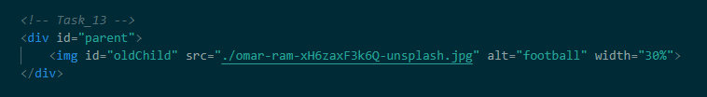

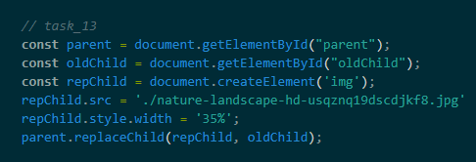



* Design a page with two sections. Upon clicking a button, swap the positions of these sections using the document.replaceChild(new, old) method.

**Solution:**

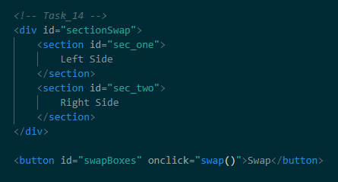

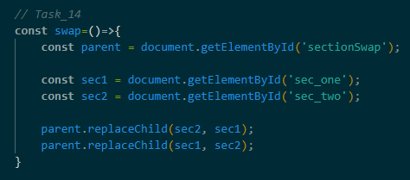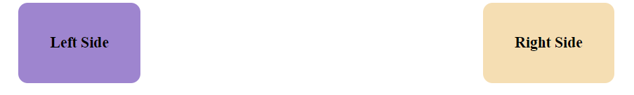

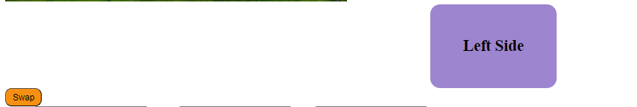

* Create a simple website layout with placeholders. Use JavaScript to replace these placeholders with actual content using document.replaceChild(new, old).

**Solution:**

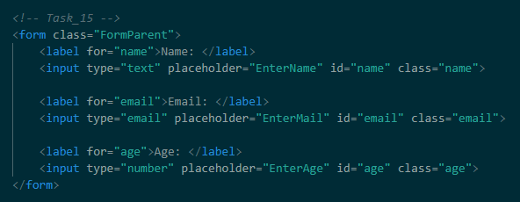

* Create a button on a webpage. Attach an event listener using addEventListener to change the button's text to "Clicked!" when it's clicked.

**Solution:**

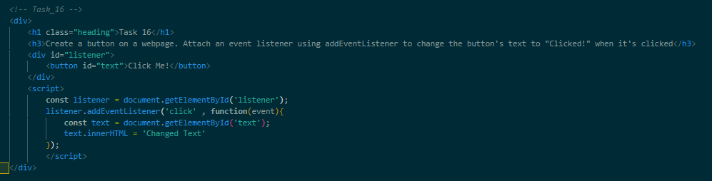

 

* Design an image that changes its source to another image when hovered over by the mouse pointer. Use the mouseover and mouseout events to achieve this effect.

**Solution:**

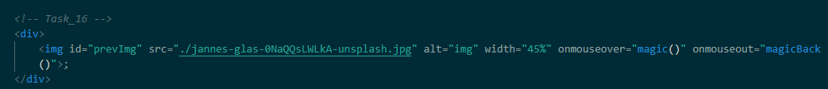

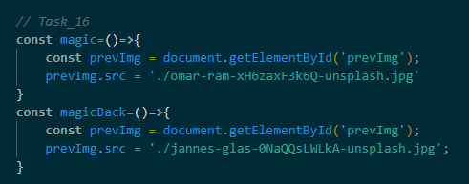





* Build a registration form with input fields for name, email, and password. Use the submit event on the form to validate that the password is at least 8 characters long. Display an error message if the validation fails.

**Solution:**

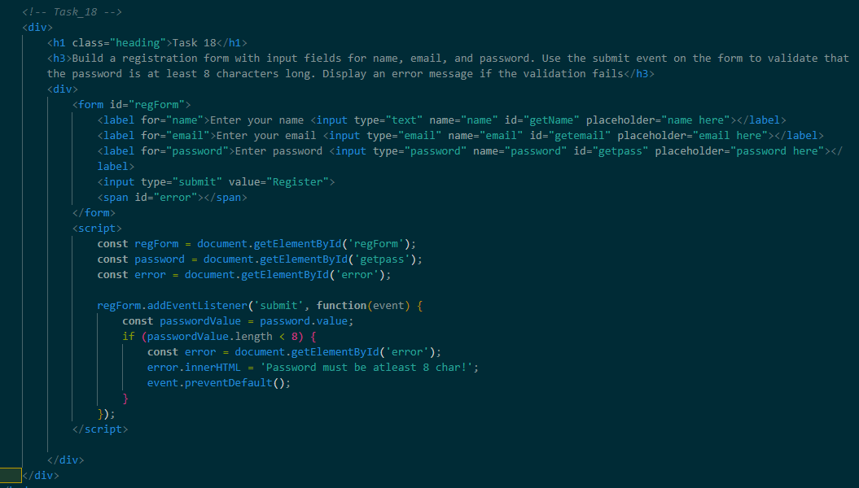



* Create a text input field. Use the keydown event to count and display in real-time the number of characters entered in the input field. Update the count as the user types.

**Solution:**